National School of Business Management
LAB Sheet 04
Lab 04 Static routing
Set up the following scenario on Packet tracer/physical
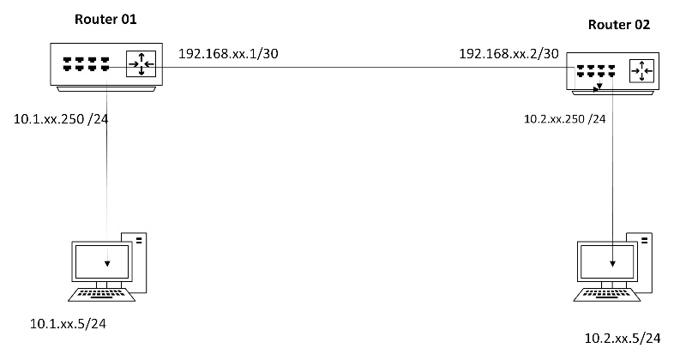

Note :- please reset the routers before you start
Step1. Identify the two different ports in the routers

Step2 Assign IP
- Assign an Interface IP to the relevant ports and Ethernet card of the computers
Ip interface must be in the following format on IPv4
10.1.X.250 / where the group number in single digit eg group 3 will configure it as 10.1.3.250

Step3 Testing basic connectivity
- Use the basic ICMP command

Step 4 Adding static routes
- The routers need to be configured to handle manual statis and must be tested if it,s

You may use the following commands to carry out the task

No | Disruption | command
01 | Switch to configuration mode – configuration terminal | Config t
02 | Switch to enable mode of a switch /router | Enable
03 | To go to interface physical | interface FastEthernet 0/0
04 | Change name Name | name
05 | Prevent the port switch off | No shoutdown
06 | Adding a static rout | ip route (network ip address) (subnet Address) ( next hop Ip address)

